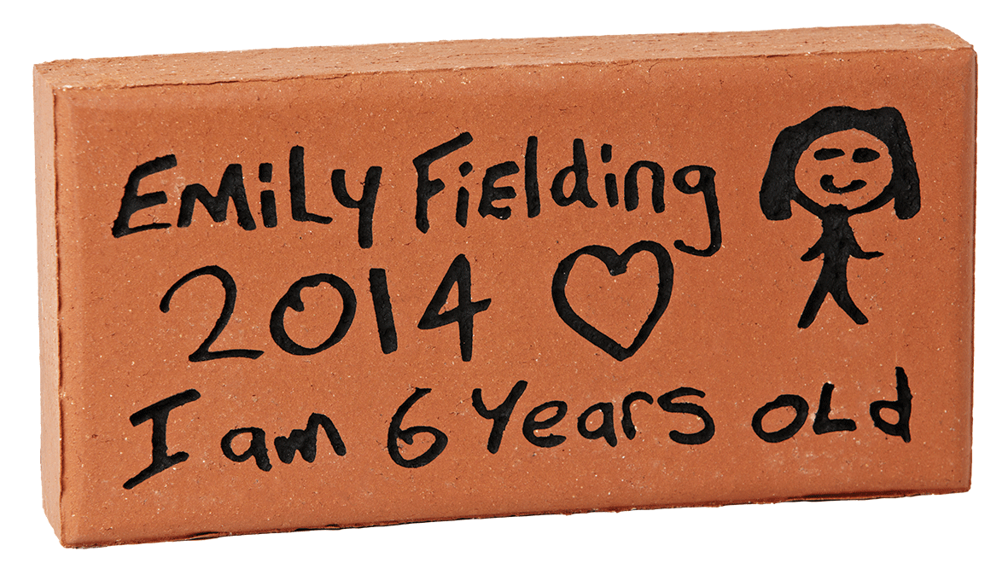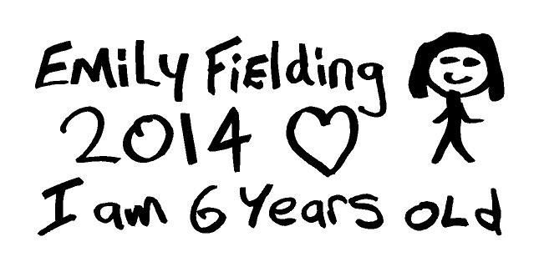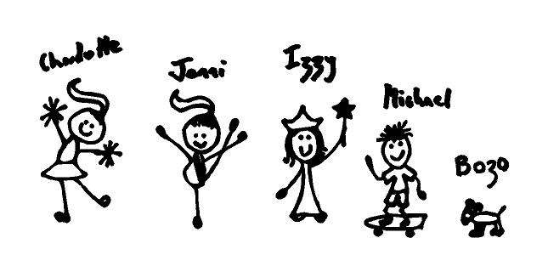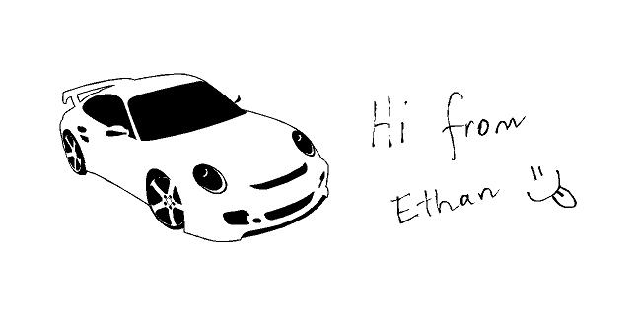

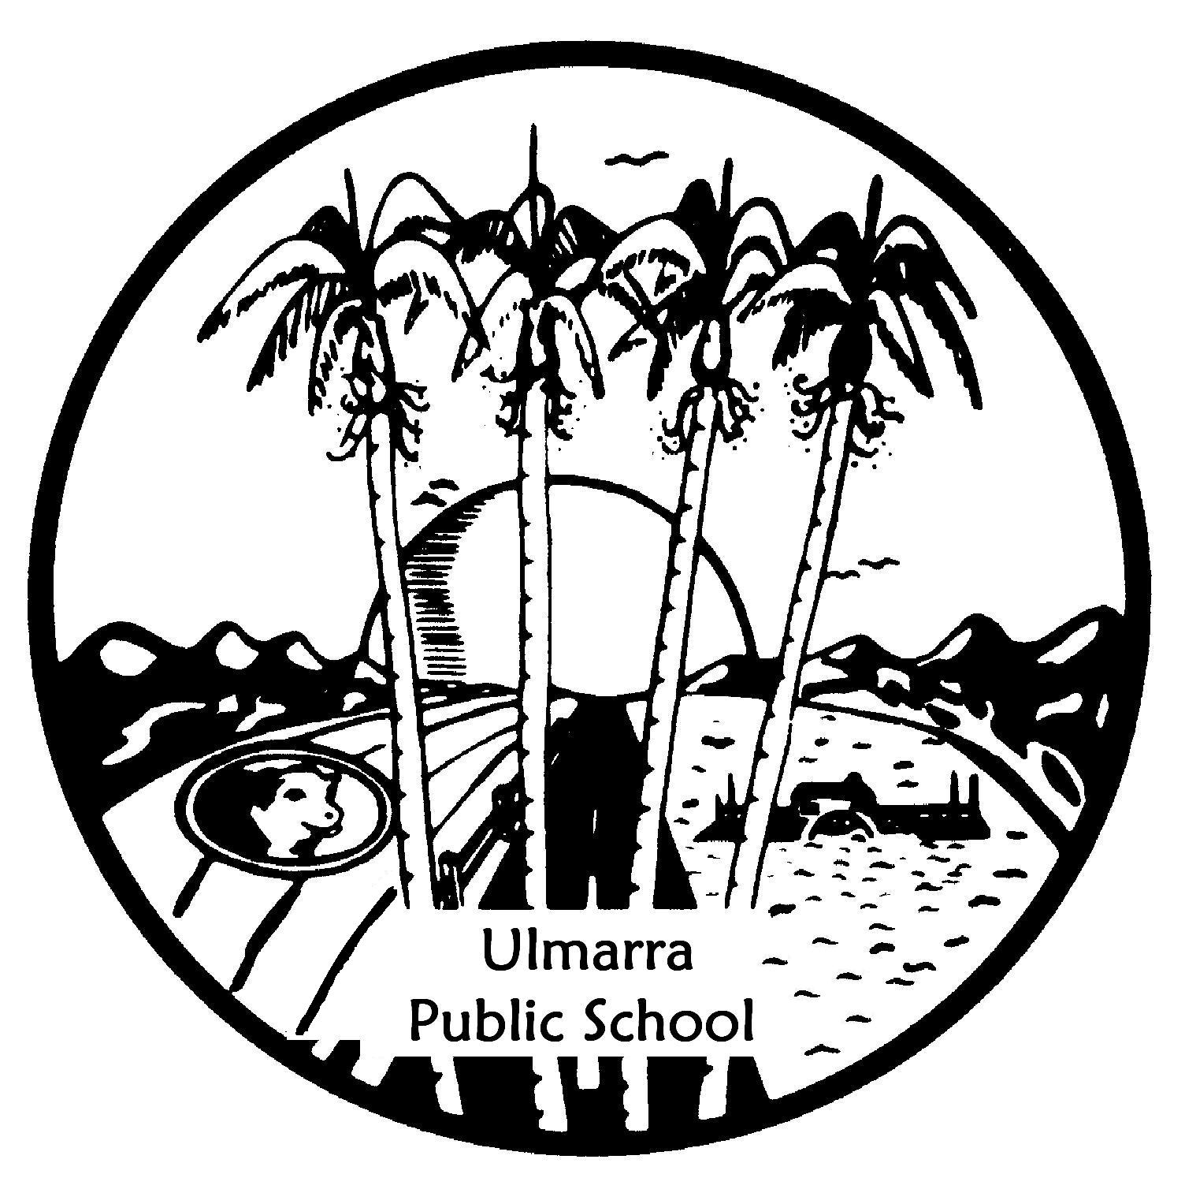

© 2014 Signature Engraving - www.signature-engraving.com.au V: 2.0

HAND DRAWN

TEMPLATE

Your donation of $25 entitles you to have your hand drawn image engraved into a brick as a lasting record of your valued support. The paver will be permanently installed in

**Ulmarra Public School Quasquicentennial Garden**

proudly showing your donation.

OFFER: $25

HAND DRAWN DETAILS

Please follow the instructions below and overleaf to ensure your drawing details are not lost during the engraving process.

1. If you do not use the template over the page, keep your drawing within the dimensions of 190mm wide x 100mm deep.
2. ONE NAME PER PAVER.
3. Artline 70 ‘High Performance’ permanent marker is the preferred and recommended marker to use.
4. NO colour pencils, colour textas, Biro’s etc will be accepted.

See over for further instructions and template.

For

Please copy and pass on to any friends & family.

**We Need Your Support!**

|  |  |  |  |  |  |  |  |
| --- | --- | --- | --- | --- | --- | --- | --- |
| Contact Name | | | | | | Phone | |
|  | | | | | | ( ) | |
| Street | | | | | | | |
|  | | | | | | | |
| City | | | | | | State | Post Code |
|  | | | | | |  |  |
|  | |  |  |  |  | Our Donation | |
|  |  |  |  |  |  | $ | |

Ulmarra Public School 125 Yr Celebration

Simply fill out this form and return along with full payment by cheque, cash or money order to:

**Ulmarra Public School**

**12-14 Pacific Hway, Ulmarra**

**NSW 2462**

PLEASE FOLLOW THESE SIMPLE STEPS WHEN CREATING YOUR IMAGE.

1. ONE NAME PER PAVER.

1. 2. Draw your image using a good quality medium thickness black marker pen (about 2mm thick).   
    eg Artline 70 ‘High Performance’ marker.  
    **Do not use a ballpoint pen, coloured texta or pencils!**
2. 3. Make sure you rub out any pencil lines as these will show up on the finished paver.
3. 4. Do not include computer-generated or pasted pictures.
4. The hand drawn image engraving process is set up to engrave hand drawn images only.

**Administrator note: Please photocopy this page for your records, cut out the drawing below   
and send the ORIGINAL to Signature Engraving.**

**PHOTOCOPY THIS PAGE FOR EACH HAND DRAWN PAVER.**

**PLEASE ENSURE THAT YOUR DRAWING DOES NOT TOUCH OR GO OUTSIDE OF THE BORDER**

THIS IS NOT OK ✗

• Do not include computer-generated or pasted pictures

• The process is set up to engrave hand drawn images only

THIS IS NOT OK ✗

• Too many names

• Illustrations too detailed

• Information gets lost

ENGRAVING DETAILS

HAND DRAWN

TEMPLATE

100mm high x 190mm wide

**SAMPLE 1**

**SAMPLE 2**

**SAMPLE 3**

THIS IS OK ✓

• Good clean writing

• Simple illustrations

✗

✗

✗

✗

✗