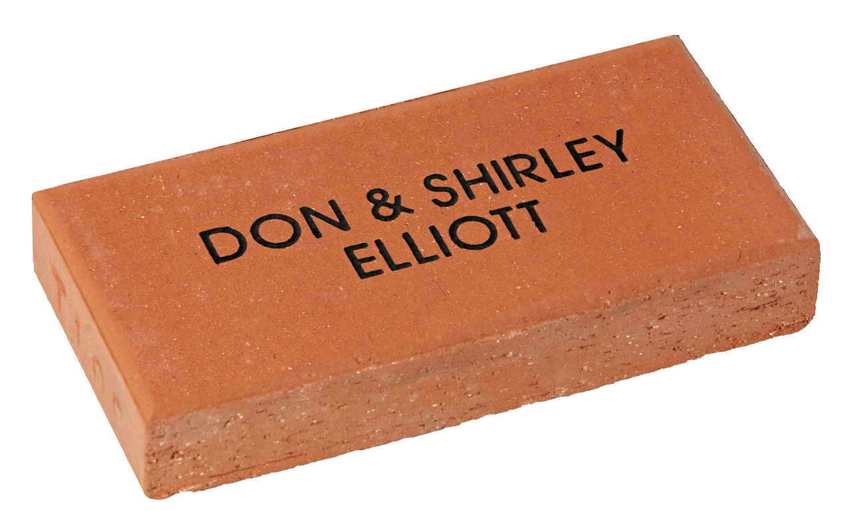



SINGLE Name PAVER TEMPLATE

|  |  |  |  |  |  |  |  |  |  |  |  |  |  |  |  |  |  |  |  |  |  |  |  |  |  |  |  |  |  |  |  |
| --- | --- | --- | --- | --- | --- | --- | --- | --- | --- | --- | --- | --- | --- | --- | --- | --- | --- | --- | --- | --- | --- | --- | --- | --- | --- | --- | --- | --- | --- | --- | --- |
| **LINE 1** |  |  |  |  |  |  |  |  |  |  |  |  |  |  |  |  |  |  |  |  |  |  |  |  |  |  |  |  |  |  |  |
|  |  |  |  |  |  |  |  |  |  |  |  |  |  |  |  |  |  |  |  |  |  |  |  |  |  |  |  |  |  |  |  |
| **LINE 2** |  |  |  |  |  |  |  |  |  |  |  |  |  |  |  |  |  |  |  |  |  |  |  |  |  |  |  |  |  |  |  |
|  |  |  |  |  |  |  |  |  |  |  |  |  |  |  |  |  |  |  |  |  |  |  |  |  |  |  |  |  |  |  |  |
| **LINE 3** |  |  |  |  |  |  |  |  |  |  |  |  |  |  |  |  |  |  |  |  |  |  |  |  |  |  |  |  |  |  |  |

Simply fill out this form and return along with full payment by cash, cheque or money order to:

**Ulmarra Public School**

**12-14 Pacific Highway, ULMARRA**

**NSW 2462**

|  |  |  |  |  |  |  |  |
| --- | --- | --- | --- | --- | --- | --- | --- |
| Company/Contact Name | | | | | | | |
|  | | | | | | | |
| Street | | | | | | | |
|  | | | | | | | |
| City | | | | | | State | Post Code |
|  | | | | | |  |  |
| Phone | |  |  |  |  | Our Donation | |
| ( ) |  |  |  |  |  |  | |

© 2014 Signature Engraving - www.signature-engraving.com.au V:2.0

Please copy and pass on to any friends & family.

**We Need Your Support!**

SINGLE NAME PAVER: $20

Your donation of $20 entitles you to have your name engraved into a paver as a lasting record of your valued support. The paver will be permanently installed in

**Ulmarra Public School Quasquicentennial Garden**

proudly showing your donation. Size: 230 x 115 x 40mm

NAME PAVER

Please print clearly in block letters. Each box represents a character (letter, number, punctuation mark or space).

Max 16 characters per line, three lines per brick. (No hand drawings.)

ENGRAVING DETAILS

Ulmarra Public School 125 Yr Celebration