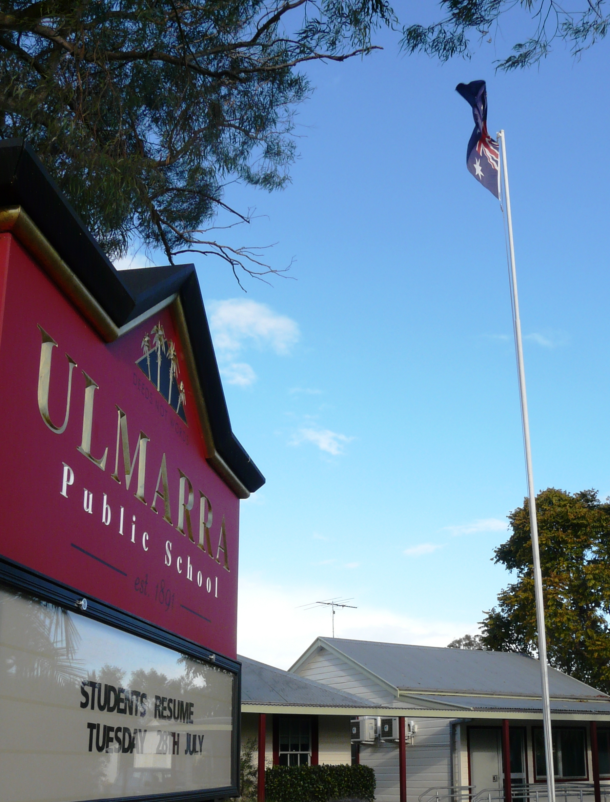


Deeds Not Words

ULMARRA PUBLIC SCHOOL

Excellence Innovation Opportunity Success

MISSION STATEMENT

To create a welcoming, attractive and stimulating environment:

- where there is an emphasis on personal development across all learning areas.

- where there is open and effective communication links with parents and the community.

- where pupils are responsible for their own behaviour by understanding their rights and responsibilities.

- where pupils are treated as individuals and strive for excellence.

- Where staff, students and the school community follow the 7 Habits –

- Be Proactive
- Begin with the End in Mind
- Put First Things First
- Think Win/Win
- Seek First to Understand, Then to Be Understood
- Synergize
- Sharpen the saw
Our School Wish

This is our school, let peace dwell here.
Let the rooms be full of contentment.
Let love abide here.
Love of people,
Love of nature and love of life itself.
Let us remember, that as many hands build a house,
So many hearts make up a school

KNOW YOUR SCHOOL

Ulmarra Public School

WELCOME
The staff of Ulmarra Public School, in conjunction with the P & C Association extend a sincere welcome to you all. We trust that your association with our school will be a happy, rewarding, educational and social experience.

Address: 12-14 Pacific Highway
ULMARRA NSW 2462
Telephone: 02 66 445 266
Fax: 02 66 445 373
Email: ulmarra-p.school@det.nsw.edu.au
Web Address: www.ulmarra-p.schools.nsw.edu.au
Facebook: facebook.com/pages/Ulmarra-public-school/1444733752474427
Principal: Mrs Vanessa Cavanagh

STAFF
Year Kinder / Yr 1 - Miss Nicole Munns
Year 1/2/3 - Mrs Kate Edwards & Mrs Kym Stockton
Year 4/5/6 - Mr Jye Reardon
Computer Co-ordinator - Mrs Vanessa Cavanagh
Transition - Mrs Kate Edwards
Administration Manager - Mrs Karen McSwan
Library - Mrs Cheryl Connor
RFF/Drama - Mrs Shannon Spring
STLA - Mrs Vanessa Cavanagh
School Learning Support Officers - Ms Emma Cowan & Mr Andrew Ellaby
Administration Officer - Mrs Belinda Connor
General Assistants - Mr John Sullivan & Mr Lawrence Mearing
Cleaning - Ms Judy Lockhart

SCHOOL TIMES
9.15am – 3.15pm.
Lessons commence at 9.15am and conclude at 3.15pm.
Recess - 11.15am – 11.45am.
Lunch - 1.30pm – 2.15pm.

It is important that pupils are not in the school grounds before 8.45am unless arrangements have been made with the Principal.

Our School colours are red and white.

PLAYGROUND SUPERVISION
A teacher is on duty in the playground for the 8.45am – 9.15am period and for recess and lunch time. Bus duty each afternoon is supervised. Teachers are supervising all students when they are on playground duty, so impromptu parent meetings take away from that supervision and care.
Town pupils (walking or riding bicycles) will not leave the grounds until the supervising teacher releases them. If your child is not travelling home in the usual manner e.g. is being picked up by someone else, is not catching the bus home or is going home with someone else please send a note to school.

SCHOOL HOURS
Parents are reminded that school officially begins at 8:45 when a teacher is on duty. Students should not be at school before this time as there is no supervision provided until 8:45. We understand there are times will students need to be earlier. They will sit quietly under the C.O.L.A. until the duty teacher arrives and dismisses them for play.
Classes conclude at 3:15 and it is preferable that parents do not arrive before 3:00pm to wait for their children as lessons are still being held and the noise under the C.O.L.A can be quite disturbing to students concentration.

STUDENT TRANSPORT SCHEME
All students from Kindergarten, Year 1 and Year 2 are eligible for free bus travel irrespective of the distance from home to school. Year 3 – 6 students who are living more than 1.6km by road from the school are eligible for free bus travel. Parents who drive their children to the nearest bus stop may also be eligible for Private Vehicle Conveyance. Private Vehicle Conveyance subsidy is available for eligible school students where there is no public transport for all or part of the journey. Forms need to posted to the Department of Transport as requested on the form. Please see the office for more information and application forms.

The Roads and Traffic Authority has appointed Crossing Supervisors, between the hours of 8.15 and 9.30am and again between 2.45 and 3.45pm. This method of supervision has been organised to safeguard your children.

Your co-operation in the following would be of assistance:
- Notify the class teacher in writing if your child/children will not be using the usual transport facilities.
- If you are calling for your child ensure the duty teacher has been informed.
- Insist that your child uses the pedestrian crossing at all times.
- Children are to use the front gate not the South double gate or the North double gate, which are both used by cars entering and leaving the school premises.
- Parents picking children up at 3.15pm are requested to do so from the school assembly area. No child is to walk to the school car park until collected by a parent / carer from the COLA.

DEPARTMENTAL ENROLMENT PROCEDURES
Children who attain the age of 5 years prior to the 1 August in that year may be enrolled at the beginning of the school year. This policy allows for the enrolment of children from the age of 4 years 6 months.

Changes to the NSW Public Health Act means that from 1994 children starting school in Kindergarten must present a birth certificate, an Immunisation Certificate and proof of address e.g. Council rates notice at the time of school enrolment.
THE RIVER TO SEA TRANSITION TO SCHOOL PROGRAM
Transition is a program for children who will be attending kindergarten the following year.
The River to Sea Transition to School Program, Ulmarra Campus, began its operation at the beginning of 2010 and has run Tuesdays since. Why “River to Sea”? Ulmarra and Wooli Public Schools, members of the Clarence Valley Community of Small Schools, offer Transition to School Programs. The name “River to Sea” reflects both the link between home and kindergarten and the location of our two schools. The program’s aim is to give each child a smooth transition to school, identifying areas to work on as well as areas of strength to develop. River to Sea transition is not an alternative to preschool and children should continue to attend preschool each week. Transition is complimentary to the preschool program and along with preschool, supports and prepares children for “big school”. The River to Sea Transition to school program will continue in Terms 3 & 4.
Fees for River to Sea Transition to School are $50 per child per term. These fees go toward the cost of teaching resources and the Graduation Ceremony.

LATE ARRIVAL / EARLY DEPARTURE
If your child is late arriving to school or needs to leave school early please sign them in or out through the school office and collect a note to give to class teacher.

CURRICULUM
The curriculum consists of all the learning experiences, which take place under the auspices of the school.
There are six key learning areas in the primary curriculum:

1 English:

2 Mathematics:

3 Science & Technology:

4 Human Society and Its Environment (HSIE)

5 Creative and Performing Arts (CAPA):

6 Personal Development Health and Physical Education (PD/H/PE)

Ulmarra Public School places a strong emphasis on the teaching of ‘basics’ in education. School programs are designed to cater for all children and to improve learning outcomes for all students.
In addition, the school aims to provide opportunities for children to develop the knowledge, skills and understanding necessary for them to become involved in the broader community. Our goal is to prepare them for responsible citizenship, further learning and productive working lives.
We also invite parents to visit the school and be involved in the educational programs of the school. The educational development of children is very much a partnership between the school and the parents/carers and you can do much to assist the school and the teachers and contribute to your child’s growth. Parents are encouraged to attend the assemblies held in the school library on Fridays at 11.45am.
Parents can assist in a variety of areas: home reading program, computer instruction/supervision, sports carnivals, covering library books, art lessons, maths groups, gardening, canteen and P & C Meetings.
Any help you can give in any way is much appreciated.

FACILITIES

CANTEEN
The P & C Association operates a Canteen on Tuesday and Thursday of each week, unless otherwise advised, and an excellent menu is provided. Parents operate this on a voluntary basis. The offer of assistance by any family is very much appreciated.

CLASSROOMS AND LIBRARY
Ulmarra Public School classrooms are fully carpeted, air conditioned and well resourced with a wide range of excellent educational materials for children of all ages and abilities. A newly constructed and well-stocked Library provides ample opportunity for quiet reading and research work to be pursued. The library also has video conferencing facilities and an interactive whiteboard as part of the Statewide Connected Classrooms Project.

TECHNOLOGY
The importance of the role of technology in education is well recognised throughout Australia. In order to be informed and active participants in our changing society, students now and in the future, will need to be self-directed learners, able to identify issues, pose questions, synthesize ideas and develop solutions to problems.
Ulmarra Public School is well resourced in the area of Information & Communication Technologies (ICT). We have a computer lab as well as computers in all classrooms, digital still cameras, an underwater camera, a digital video camera, ipads laptops and a data projector. Interactive whiteboards are installed in all classrooms. Our school also has two Connected Classrooms with video conferencing facilities.

Students at Ulmarra Public School participate in activities that assist in the development of their ability to:
- Use computer-based technologies to locate, access, evaluate, manipulate, create, store and retrieve information;
- Express ideas and communicate with others, using computer-based technologies;
- Discriminate in the choice and use of computer-based technologies for a given purpose;
- Develop the confidence to explore, adapt and shape technological understandings and skills in response to challenges now and in the future.

COVERED OUTDOOR LEARNING AREA (COLA) AND PLAYGROUND
The covered area for lunches, assemblies and related school activities is a great asset to the school complete with educational games marked on the concrete. Fixed playground equipment, tennis practice wall, cricket pitch, soccer and netball fields provide ample opportunity for developing fitness and sporting skills.

SCHOOL PRIORITIES
Getting the Foundation Right
- To effectively implement Department of Education and Communities policies and curriculum
- To develop appropriate and challenging programs that meet the needs of all students.

Excellence in Teaching and Learning
- To develop knowledge and understanding of curricula.
- To optimise learning outcomes for all students.

Partnerships in Public Education
- To develop positive community attitudes to the school.
- To encourage and maintain community participation and involvement in the school.

Safe, Challenging and Creative Schools
  - Provide a challenging and friendly environment in which children and adults feel safe, secure and self-confident.
  - Promote equity of educational outcomes and opportunity for all children.
  - Ensure effective use of resources.

REPORTING ON STUDENT PROGRESS
Parents place a high priority on receiving information about their children’s progress at school. Ulmarra Public School parents receive information on student progress through a written report from teachers at the end of each semester. These reports compare student progress to the standard expected by the syllabus. A detailed teacher comment adds further information by making specific reference to aspects of student performance as is relevant to the standards expected by the syllabus.
Parents are also informed about their children’s achievements through reports from external tests such as the National Assessment Program Literacy and Numeracy (NAPLAN), Best Start Assessment, class tests and through homework and informal discussions with their children and with teachers.

EXCURSION PROGRAMME
Excursions are an important part of the education process and provide a wide range of learning experiences for the children. They are planned with the educational interest and needs of the children in mind and provide an important supplement to the learning programs of the school.
All excursions are organised with the aim of keeping cost to a minimum.

SPORT
We have a policy of providing sporting opportunities for all children regardless of their ability. All pupils have the opportunity to participate in inter-school sports with surrounding schools. The school runs its own Athletics Carnival and Cross Country Carnival at school and joins with other small schools for the Swimming Carnival at Grafton Pool.
In all sports children are encouraged to participate and to achieve their potential. The school is proud of the outstanding records of its teams and individual performances over recent years.

BOOK CLUB
The school offers the facility of the Ashton Scholastic Book Club, which provides the children with the opportunity to purchase books for home reading at a reasonable cost. The school library benefits by receiving bonus books from Ashton Scholastic.

SCHOOL BANKING
The school offers a Commonwealth banking service on Tuesday of each week. Each student that banks receives a token. Tokens can be saved up to collect a range of prizes. Any enquiries can be directed to the school.

SCRIPTURE
Scripture classes are conducted at the school each week. Children, unless we have been otherwise directed, will remain in class in their class groupings for these 30 minute lessons. Religious instruction will be given to them according to a curriculum that has the approval and blessing of the regions concerned. Our thanks are extended to the Scripture Teachers for their dedicated service.

LIBRARY
The sharing of library books with parents is important to a child developing a “love of reading” and we strongly urge all parents to actively encourage their child/children in their borrowing and to be involved in sharing (reading or talking about) books from our well resourced school library.
Kindergarten class will only borrow books for reading within the classroom but students in Years 1 - 6 will be expected to borrow books for silent reading in the classroom and for home.
To be allowed to take a book home, students must have a library bag. This could be a strong plastic bag, a cloth ‘library’ bag or simply a pillowcase. This will ensure the books are protected in their journey to and from school. Wednesday is our library day.

CLOTHING
Parents are reminded that names should be clearly marked on pupil’s clothing and other property including pencils etc. This allows lost property to be returned quickly to the rightful owners. At the end of each term unclaimed clothing will be laundered and added to the Clothing Pool. A clothing pool is available for parents to access. Donations of school uniforms are always appreciated.

PARENTS & CITIZENS ASSOCIATION
Our school is fortunate in having a very active and supportive P & C Association. Activities such as family days, fetes, sausage sizzles, trivia nights, bush dances, working bees, auctions, discos, morning teas etc are organised on a regular basis throughout the year. Money raised is used to buy resources for the school and to subsidise the cost of excursions.
The P & C Association meets at 5.30pm on weeks four and eight of each term in the school library. All parents are invited and welcome to attend.

LEARNING RESOURCE CONTRIBUTION
The Learning Resource contribution scheme is set at $40.00 per family per year. The money collected by this contribution covers the use of students’ writing books, purchase of library books, teaching resources, educational aids, computer hardware and software, sporting equipment, photocopiers etc that the school needs to support all educational programs.
The school thanks you for your support with this voluntary contribution.

SCHOOL ASSISTANCE SCHEME
An amount of money has been allocated by the Department of Education to assist families in purchasing textbooks, helping with uniform purchases, excursion or sporting activities for school. Any parent/carer wishing to access this money must fill in the relevant form at the office. All requests are treated confidentially.

NEWSLETTERS GOING GREEN
As a school recognised for our recycling and reducing waste, Newsletters in a paper format will only be available to Kindergarten, families who have asked and the ones available to the community. The newsletter is posted each fortnight on our school webpage and is accessible this way or can be sent through via email. Please let us know which form you would prefer.

SCHOOL UNIFORMS AND HATS

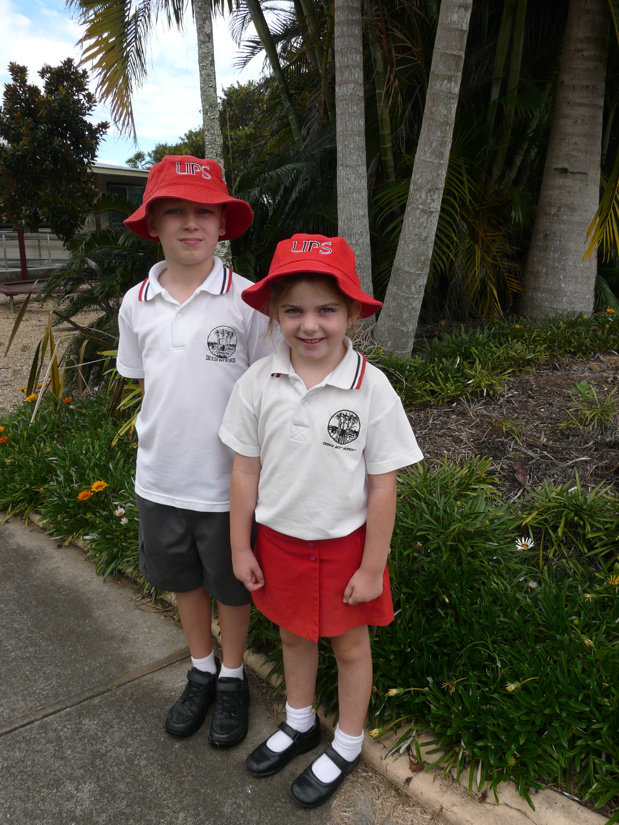

The uniform items listed below are available from Sea Eagle Fashion at 249 River St Maclean.
The phone number is 66 453 778. The shop is open 9am – 5pm from Monday to Friday.
Shirt, Skorts, Grey Shorts, Jacket, Tracksuit Pants, Fleece Jumper, Fleece Pants
School hats can be purchased from the office and cost $9.00 each.
All new enrolments receive a free hat.

PARKING OF VEHICLES IN SCHOOL GROUNDS
Permission to park on school sites during school hours is granted as a privilege. The Department does not accept responsibility for damage to or loss of any vehicle parked within school grounds. The school has car parks situated on the northern and southern end of the school

SCHOOL PARLIAMENT
At Ulmarra Public School our leadership programs promote citizenship and an understanding of the democratic process. They assist all students to learn about, and exercise their rights and responsibilities as participants in a community that values social justice. Our School Parliament provides opportunities for students to make decisions that affect them in their school environment. All students have the opportunity to develop and demonstrate leadership skills. The School Parliament is an important strategy for promoting equity, responsibility and positive values and attitudes.
Through the School Parliament, students develop:-
- active and reflective listening skills
- critical and creative thinking
- communication and negotiation skills
- mediation and dispute resolution
- problem solving and decision making
- goal setting and action planning
- an increased sense of pride in and ownership of their school

STUDENT ORGANISATION
School Captains, House Captains and School Parliament Cabinet Ministers are elected for the whole year.

SPORT HOUSES
Ulmarra School has been divided into three houses, HOLLAND, SMALL and FIRTH. Students are allocated to a house and generally will remain in that house during their stay at Ulmarra School. House Captains and Vice Captains are elected to lead and organise each house competition.
Athletic and Swimming carnivals are held where the houses compete for shields, donated by members of the community. Mr. Reardon is our Sports Coordinator.

House colours:
SMALL Green
HOLLAND Red
FIRTH Yellow

CLASSROOM REQUIREMENT
It is so important for all children to have their own belongings. This makes the day run smoothly with children not wandering around disturbing others looking for a pencil, eraser etc. All items need to be labelled.
Class Requirements 4/5/6:
Items required are 4 lead pencils, ruler, 2 A4 display folders, eraser, coloured pencils, textas (optional), scissors, pencil sharpener, tissues, glue stick, a painting shirt and a library bag for borrowing.
Class Requirements 1/2/3: Items required are 4 lead pencils, ruler, eraser, coloured pencils, textas (optional), scissors, pencil sharpener, glue stick, one plastic A4 wallet, a painting shirt and a library bag for borrowing.
Class Requirements K/1: Items required are 4 lead pencils, ruler, eraser, coloured pencils, scissors, pencil sharpener, glue stick, two plastic A4 wallets, a painting shirt and a library bag for borrowing. It is preferable that these pencil cases are not too large.

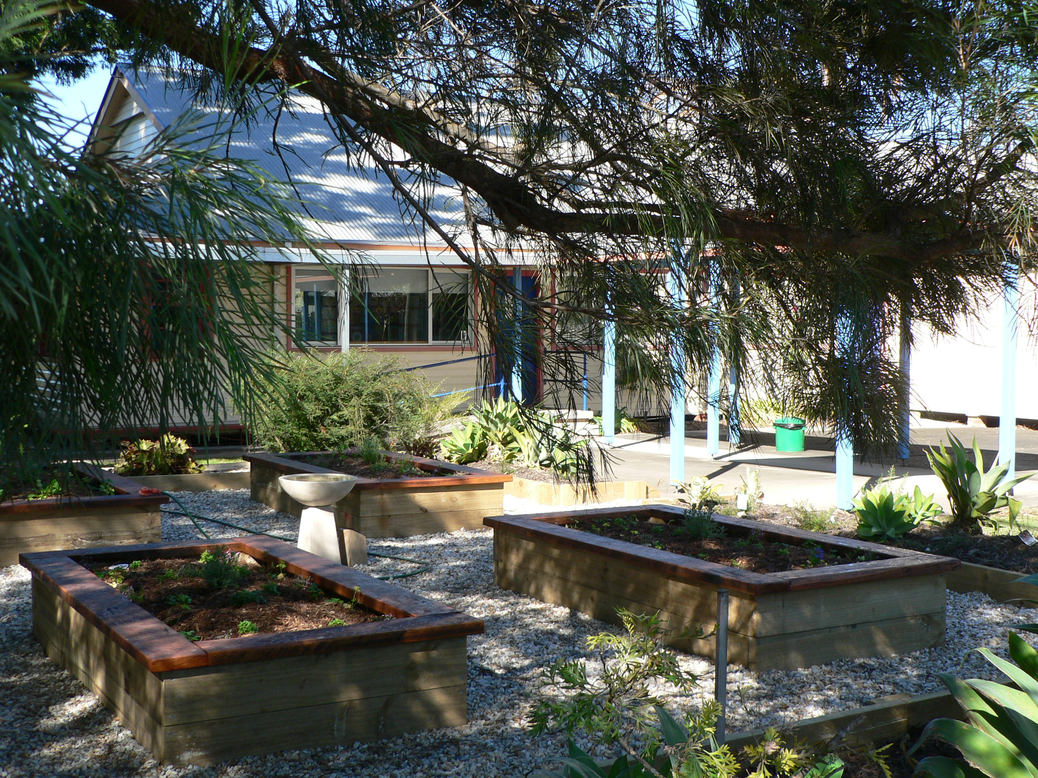
SPECIAL PROGAMS

THE LEADER IN ME
You may have heard of Stephen Covey’s book, “The 7 Habits of Highly Effective People”. It was first published over 20 years ago. Simply put, by following the 7 Habits people are able to better organise and approach their lives. Living by these principles makes people more successful and more effective.
The principles are timeless. They worked 100 years ago. They work today and they will work a 100 years from now.
What are the 7 Habits?
- Habit 1: Be Proactive – you’re in charge
- Habit 2: Begin with the End in Mind - Have a plan
- Habit 3: Put First Things First - Work first, then play
- Habit 4: Think Win/Win – Find a solution where everyone wins
- Habit 5: Seek First to Understand, Then to Be Understood – Listen before you talk
- Habit 6: Synergize – Work in a team
- Habit 7: Sharpen the saw – Balance feels best
The 7 Habits do not only benefit adults, they benefit children as well. Ten years ago, a primary school in the U.S.A. adapted the 7 Habits to suit children and called the program “The Leader In Me”.
In this context, leadership means being able to lead your own life to fulfill your potential and achieve happiness and success. Everyone can be a leader.
Schools participating in the program report that cultural changes impact upon the following dimensions of their schools :
- improved academic outcomes
- reduced behaviour referrals
- increased student self confidence
- promotion of 21st Century life skills
- increased teacher satisfaction and professional development
- greater parent satisfaction and engagement
- engaged local business communities.

At Ulmarra Public School, the timeless values and principles that are the 7 Habits, underpin all we do. They create a solid foundation for 21st century learning.

THE CINELITERACY PROJECT
Cineliteracy is a DEC project, began in 2003 at Ulmarra Public School. Filmmaking is part of the Stage 3 class program and encourages students to both “read and write the screen”. Cineliteracy promotes the development of reading, writing and creative and practical arts via the medium of film. The films are screened at the Big River Public School Film Festival along with films from other Public Schools.

CLARENCE VALLEY COMMUNITY OF SMALL SCHOOLS
We enjoy our small school atmosphere. It is unique and often celebrated.
Ulmarra Public School is well resourced and our students have more play space, smaller class sizes, much greater access to computers and other information technologies, more opportunities to be a school leader and generally a safer and more community minded learning place than what can be offered in the large school setting.
There are times however, when we want to be a “big school” without the problems that go with it. It is from this desire that the Clarence Valley Community of Small Schools was formed.
Ulmarra Public School joins with Wooli Public School for cultural events, curriculum focus days and excursions to Sydney and the Great Aussie Bush Camp. Other local small schools join with us for sporting events and interschool academic challenges. At such times numbers exceed over 600 students.
These special events also allow our students to form friendships with students from other schools making the transition to high school an easier one.
The Clarence Valley Community of Small Schools has been recognised as an exemplar model statewide and we are justly proud.

PERCEPTUAL MOTOR SKILLS PROGRAM (PMP)
PMP is a research-based program developed by a former Kindergarten teacher and a Principal. It provides children with a wide range of multi-sensory experiences in seeing, hearing, touching, making perceptual judgments and reacting. It is sequentially structured so that the child gains a progressively higher order of skills. PMP aims to introduce basic movement patterns prior to the teaching of Fundamental Motor Skills such as kicking, throwing, catching, dodging and hitting. It aims to prepare children for formal learning by providing training in auditory, visual, motor, social, language and memory skills and is of most benefit when it is introduced at the beginning of the Kindergarten year.

ENVIRONMENTAL PROGRAMS
Ulmarra Public School has long been recognised as a leader in environmental programs. Ulmarra Public School students decided to help reduce greenhouse gas emissions by creating a role as Power Police. Senior students roster on as Power Police, switching off all electrical appliances, fans, lights and air conditioners not in use during recess, lunch and after school. They also run a competition, rewarding the most energy efficient classroom at the end of each term. This program has heightened awareness amongst students, staff and the community of the effects of wasting electricity and has created a school of environmentally responsible students and staff. Ulmarra Public School is an accredited Water Wise School. Since implementing the program the students have a greater awareness and understanding of the importance of water and how their actions affect water in the environment.

DISCIPLINE POLICY

CORE RULES
All students in NSW government schools are expected to:
- Attend school every day, unless they are legally excused, and be in class on time and prepared to learn.
- Maintain a neat appearance, including adhering to the requirements of the school’s uniform or dress code policy.
- Behave safely, considerately and responsibly, including when travelling to and from school.
- Show respect at all times for teachers, other school staff and helpers, including following class rules, speaking courteously and cooperating with instructions and learning activities.
- Treat one another with dignity and respect.
- Care for property belonging to themselves, the school and others.
Behaviour that infringes on the safety of others, such as harassment, bullying and illegal or anti-social behaviour of any kind, will not be tolerated.

PUPIL BEHAVIOUR
All people have RIGHTS which students and teachers must observe. All students and teachers have the RESPONSIBILITY to respect the rights of other students, teachers and people who work in our school.

A RIGHT is something, which belongs to you and cannot be taken away.
A RESPONSIBILITY is something you should do to ensure that the rights of others are respected.

BEHAVIOUR CODE
1 Take care of your personal property and take pride in your work.
2 Be helpful and honest.
3 Keep your hands and your feet to yourself.
4 Be a good sport and always play by the rules.
5 Treat all people – pupils, teachers, and visitors – with respect and courtesy.
- speak politely
- treat everyone fairly
- be friendly and help others
- no bullying, teasing or name-calling
- work out problems without fights or arguments
- help new or lonely classmates
- learn self control and face up to the consequences.
6 Uphold your school’s good name
- always wear school uniform
- be well behaved on buses, excursions and all special occasions
7 Respect school property
- take care of all buildings and equipment
- take care of gardens and shrubs
- keep the playground clear of litter
- look after your classroom.
8 Keep our playground safe.
- bullying, teasing or name-calling should worry no one
- stay within the school boundaries
- keep clear of unsupervised areas
- walk your bike across the playground
Our discipline policy has been reviewed and is available on the school website.

REWARDS
In an effort to encourage good behaviour and student responsibility pupils have the opportunity to receive:
- Class awards for good behaviour and/or excellent work
- Playground awards for responsible behaviour
- Assembly awards
- Student of the Week awards
- End of Term Award
- Sports Ribbons

Any three of these awards entitles the pupil to a Merit Certificate. Three Merit Certificates or student of the week awards entitles the pupil to a Principal Award. This promotes them to SILVER LEVEL. Three Principal’s awards entitle the pupil to a special certificate and achievement of GOLD LEVEL.

Parents are asked to read this behaviour code carefully and to discuss it with their child/children. It is hoped that parents will support the code and co-operate with the school in an effort to maintain the high standard of behaviour at the school.

For more information about Ulmarra Public School please visit our website at,

www.ulmarra-p.schools.nsw.edu.au



